**Name: RESHMA KS**

**Roll No:27**

**Batch :MCA-B**

**Date:01-09-2022**

**DATA SCIENCE LAB**

**Experiment No: 1**

**Aim**

 Programs to handle data using pandas.

**Question**

**Q1 - Pandas  Series**

1. How to create Series with nd array
2. How to create Series with Mutable index
3. Creating a series from a Dictionary
4. Print all the values of the Series by multiplying them by 2.
5. Print Square of all the values of the series.
6. Print all the values of the Series that are greater than2
7. Addition of two series
8. Print the first and last 5 elements of a series
9. Print the values from index 0 to 5
10. Selection Using loc, iloc index label
11. Retrieve subsets of data using slicing

**Procedure**

1.How to create Series with nd array

import pandas as pd

import numpy as np

arr=np.array([10,15,18,22])

s = pd.Series(arr)

print(s)

**Output**

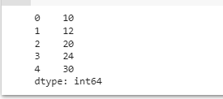

2. How to create Series with Mutable index

import pandas as pd

import numpy as np

arr=np.array(['a','b','c','d'])

p=pd.Series(arr, index=['first','second','third','fourth'])

print(p)

import pandas as pd

x = pd.Series(50 , index=[20,30,40,50])

print(x)

**Output**

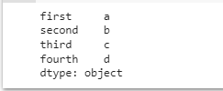

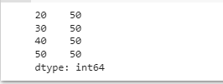

3. Creating a series from a Dictionary

import pandas as ps

d = {'name' : 'kia', 'phone' : 98563953, 'runs' : 1500}

y = pd.Series(d)

print(y)

**Output**

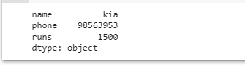

4. Print all the values of the Series by multiplying them by 2

import pandas as pd

p=pd.Series([1,2,3,4,5])

print(p)

print("multlipling all values in series by 2")

print(p*2)

**Output**

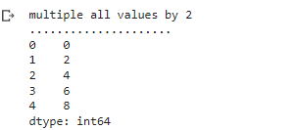

5.Print Square of all the values of the series

import pandas as pd

p=pd.Series([1,2,3,4,5])

print('..............................................')

print("square of all values")

print(p**2)

**Output**

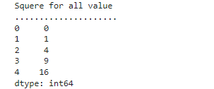

6 Print all the values of the Series that are greater than2

import pandas as pd

p=pd.Series([1,2,3,4,5])

print("when the value greater than 2")

print(p[p>2])

print('..............................................')

**Output**

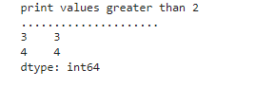

7. Addition of two series

import pandas as pd

s1=pd.Series([1,2,3,4,5],index=['a','b','c','d','e'])

s2=pd.Series([10,20,30,40,50],index=['a','b','c','d','e'])

s3=pd.Series([5,14,23,32],index=['a','b','c','d'])

print("Add S1 and S2")

print('.....................')

print(s1+s2)

print("Add S2 and S3")

print('.....................')

print(s2+s3)

print("Add S2 and S3 and filled non matching index with 0")

print('.....................')

print(s2.add(s3,fill_value=0))

**Output**

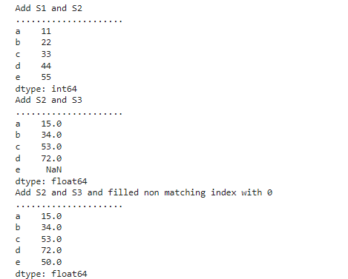

8. Print the first and last 5 elements of a series

import pandas as pd

import numpy as np

arr=np.array([10,12,23,3,4,56,57,6,7])

s=pd.Series(arr)

print(s.head(5))

**Output**

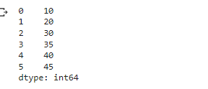

9. Print the values from index 0 to 5

import pandas as pd

import numpy as np

arr=np.array([10,12,23,3,4,56,57,6,7])

s=pd.Series(arr)

print(s.head(6))

**Output**

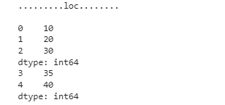

10.Selection Using loc, iloc index label

import pandas as pd

import numpy as np

arr=np.array([10,12,23,3,4,56,57,6,7])

s=pd.Series(arr)

print(s)

print(s.loc[:2])

print(s.iloc[3:4])

**Output**

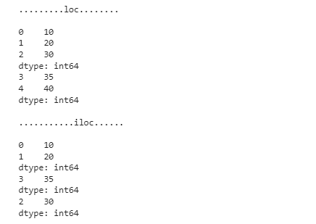

11. Retrieve subsets of data using slicing

import pandas as pd

import numpy as np

arraa=np.array([10,15,20,25,30,40])

f=pd.Series(arraa,index=['A','B','C','D','E','F'])

print(f)

print(s[1:5:2])

print(s[0:6:2])

**Output**

